OpenFloo : Optimizing Network Data Paths for Virtual Machines
By- Vedang U Manerikar, Ketaki N kulkarni, Chirayu P Shah, Jitesh H Shah
(With invaluable inputs from : Kedar Sovani, Henry Nestler. Special Thanks to Dan Aloni)

Problem Definition:
To support shared memory communication among multiple running virtual guest OS on ring 0. A virtualization software called coLinux is used which enables linux to run on ring 0, co-operatively with the host OS.
Overview of coLinux:
As mentioned previously, coLinux enables linux to run co-operatively on ring 0 along with the host OS. coLinux is basically a privileged driver in the host OS.

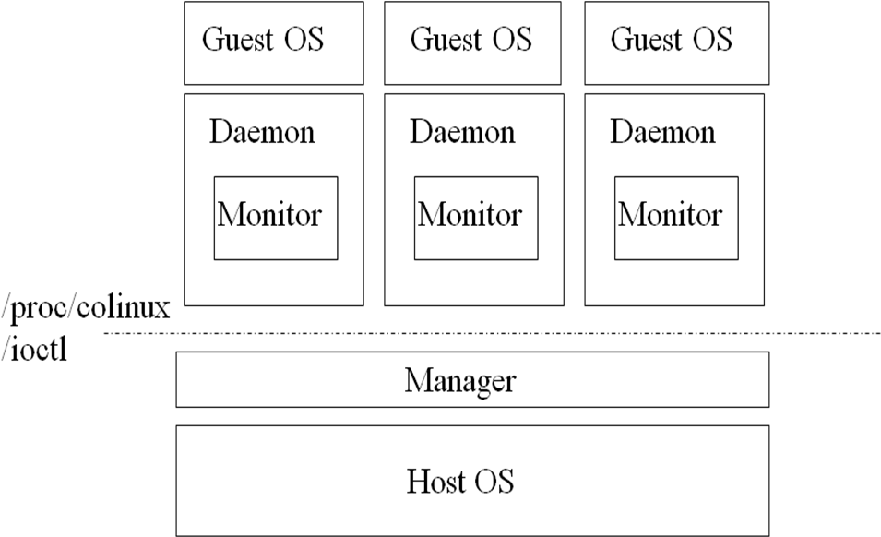

Basic architecture of coLinux (everything in ring 0)

Terms used:
- Host OS:
In virtualization, host OS is the controller OS. It manages the creation, execution, termination, memory allocation, scheduling and privileges bestowed upon the guest OS. Under coLinux, the host OS gives ring 0 privileges to the guest OS. Currently, coLinux can use either Windows or Linux as host OS.

- Manager:
Manager runs on the host OS. As there can be multiple OS running on the host, the manager keeps track of all of them. It includes, total memory allocated to the guest OS, structures to access metadata of each guest OS. Functions to boot a new guest OS or terminate a guest OS. It is vital to note that the manager structure is common to all guest OS.

- Daemon:
Daemon serves as the interface to the user level. It is associated with parsing the command line and invoking proper actions (like say, boot a guest OS, terminate it, etc). The communication among daemon and the manager is through the device file /proc/colinux/ioctl.

- Monitor:
Each guest OS is associated with a monitor. The monitor maintains all metadata about the guest OS (like, memory allocated to it, passage page, block devices, network devices, etc). The monitor also provides information to the manager about the metadata. Monitor actually boots up the guest OS, initializes the address space and initializes the passage page.

- Passage page:
Passage page is a structure which is shared among the host and the guest OS. It stores the context of both the host and the guest, the code for switching between the host and the guest. Also, messages can be passed between the host and the guest through the passage page (for eg. Guest asks the host to allocate pages, host returns the status of allocation – success or failed)
- Guest OS:
coLinux is designed to run only linux as the guest OS. The guest OS is paravirtualised, meaning it is modified so that it is aware of its “virtualized” environment. On coLinux, minimum changes are required to be made in the guest OS, since, the guest OS already runs on ring 0.

Need of the passage page: (context-switching)
(Note: i386 architecture is assumed in all of the following discussion)
For switching between the host and the guest OS, the address space needs to be changed. A change is required in both CR3 and IP. Both have to be changed simultaneously, since a) changing CR3 first would render IP meaningless and b) changing IP first is pointless since, the code to be executed is in another address space altogether. A solution to this problem is to share a temporary address space between the host and the guest. So that we can change CR3 first and then change IP to point to the code in another OS. This is achieved by using the passage page.
Another use of passage page is to implement a minimum form of communication among the host and the guest. Even though the guest OS is in ring 0, it doesn’t have access to the block devices and network devices. Also, logging, debugging the guest from the host is essential. For all these purposes passage page is used.
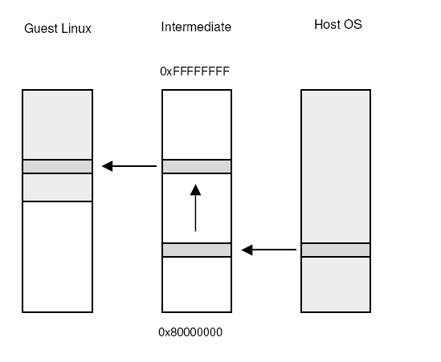
(Courtesy: Dan Aloni’s paper on coLinux at the Linux Symposium 2004)
Interrupt handling under coLinux:
Since, a context switch includes change in IDTR too, coLinux sets up its own IDTR. Interrupts for internal processor exceptions (0x00 to 0x1f) and system call vector (0x80) are kept as it is. As a result, coLinux handles its own page faults and other exceptions. All other interrupts are forwarded to the host OS, because they are needed to keep the coLinux daemon and the host OS processes running. The timer interrupt is also forwarded to the host OS, so that it can manage the scheduling of guest OS. (Passage page is vital in forwarding the interrupts).

Pseudo Physical RAM: (PPRAM)
The Linux kernel expects the entire RAM to be allocated to itself. It thus assumes that the physical RAM is contiguous. But, a guest allocates memory from the host OS and may not be contiguous. In order to give the guest OS a contiguous view of the physical RAM, PPRAM is used. PPRAM is basically a mapping from the pseudo-physical (contiguous) page frame numbers to the actual physical page frame numbers. It is used only in software by the guest kernel and should not be confused with the page tables. Also, there exists a reversed pseudo-physical mapping. It maps the actual physical addresses to the pseudo-physical addresses.

Summary:
Guest OS also on ring 0. It manages its own page tables and page-faults. Proxy interrupts and clock interrupt are forwarded to the host OS. Pseudo physical RAM is used to give the guest a contiguous view of physical RAM. Passage page is used to context switch between the host and the guest. Block devices, logging and debugging require a switch to the host OS. Minimum changes in the guest kernel code.

Communication among guest OS:
Currently, 3 methods are used for networking in the guest OS. TCP/IP stack is used in either case for communication.
- Slirp:
Slirp uses NATting to give access of internet to the guest OS. As a result, the guest OS aren’t visible to each other (they are on different networks). So, shared disk can be used as a means of communication.

- TUN/TAP:
TUN/TAP drivers provide a virtual adapter to the guest OS through which it can then connect to a network. Guest OS is then visible on the network and TCP/IP stack can be used to communicate.

- WinPCAP/libpcap:
It is a packet capture architecture. The library injects packets into the already present line. It does not work if one connects to the ISP directly and the ISP refuses multiple IP addresses on the same line. It can be used for a private network.

Shared memory communication between guests:
Network communication between guest OS degrades performance due to the presence of the network stack. We use the fact that the communicating guest OS run on the same machine and use shared memory to communicate.

Design of the shared memory architecture:
Following points are assumed while designing the architecture:
- The interface designed should be as similar to the network calls as possible. It can then be integrated with the network stack, as an alternative method of transferring packets, so that applications do not need to change.
- Keeping that in mind, we use the client-server model. A server listens to a handle (similar to “port” in the TCP/IP context). A client can connect to the handle and thus, establish a communication path. A page will be shared among the communicating OS.
- Handles are global identifiers for communication paths. A handle should be able to uniquely identify the communicating OS, the page shared among them and the processes involved in the communication.

The design:
Data structures used:
- A linklist in each guest OS identifying a process associated with the handle (i.e. the process in the guest OS which is communicating through the handle). (call it guest_handle_proc_list)
- A linklist in the host OS identifying an OS associated with a handle. (i.e. the OS which are communicating through the handle). (call it host_handle_os_list)
Guest OS

Guest OS

Guest OS

1
5
5
6
6
1
Host OS
1
2
6
3
4
5

(NOTE : diagram shows the linklists on host and the guest. The numbers in the boxes are “handles”. only 3 guest OS are shown. Eg, Guest OS 1 and 3 communicate through handle 1)

Opening a connection:
The code for communication is provided as a kernel module. A device file is used for the user interface. To listen to a handle, the user passes the handle to listen as a parameter to an ioctl call. After the regular checks for duplication, an entry is made in the guest_handle_proc_list and the host_handle_os_list. The call is then blocked until a client connects to this handle.

Connecting to a handle:
The client simply calls ioctl with CONNECT and the handle to connect as a parameter. After the regular checks for existence of a server listening to the handle, the connection is set up and the server is woken from the bind system call. A shared page is allocated.

Communicating:
The usual read/write system calls with the usual parameters are used for communicating. It should be noted that both read and write calls are blocking. That is, if read is called and the shared buffer is empty, the call is blocked until someone writes to the buffer. Inter-OS sleep/wakeup mechanism needs to be developed in such a situation. The passage page plays a vital role in implementing the mechanism.

Unregistering the handle:
The handle can be unregistered by the process itself or it is cleaned automatically when the process exits. We delete the entries from the guest_handle_proc_list and host_handle_os_list.

Inter-OS sleep-wakeup:
Server waits for the client to connect to it. The server should be woken up when a client connects to it. Also, read system call blocks when there are no messages available to read. When a writer writes to the shared page, the reader (possibly in another OS) should be woken up. The problem with this is that wake-up lists cannot be maintained across OS. We use the passage page for the purpose.
Whenever, a guest wants to wake-up a process of another guest OS, it sets a bit in the passage page of the other guest OS. In the schedule() function of the guest OS, we check the bit. If 0, we continue with the usual code. Else, we get the list of processes to be woken up from the host OS and wake them up. Note that this switch to the host OS is infrequent as compared to the frequency of the schedule() function. So, the performance hit is not too high.

Sharing a page:
The alloc_page() call in the guest OS actually gets the page from the host OS. So, if there is some method to inform the host OS that the page being asked for is for shared memory communication, the host can take appropriate actions. We use GFP mask for the same. A GFP mask gives information about the type of the page (eg. Whether the page is in high memory, for DMA, for kernel, whether to retry or not, etc). We added two more flags, namely __GFP_SHARED_COMM_SERVER and __GFP_SHARED_COMM_CLIENT. For the server, the host saves information about the allocated page. For the client, we merely retrieve the saved information, instead of allocating a new page. Thus, the page is shared.
A few issues arise with this method. If the server crashes, or closes the connection as a part of some error handling, the client must be intimated that the page is deallocated and no longer exists. If this is not done, the client might be writing to a non-existent page. A trick similar to inter-OS sleep-wakeup can be used. (again it won’t incur a visible performance hit, since, the case where server crashes is rare).

Other issues to be considered:
Should the guest execute read/write on the shared page or should it switch to the host and let it handle the shared memory. Should there be multiple readers/writer on a single shared buffer. How advantageous would it be to allocate multiple pages for a single communication path. Handling crashes of communication ends, communicating OS. Is there any advantage with limiting the number of pages a process/OS can take for communication (probably from the security point-of-view. A user can call BIND many times, and each time a page will be allocated, thus, host OS can be overwhelmed)

